# **CHAPTER III**

## METHODOLOGY

The researchers decided to utilize Agile Software Development as their methodology. The said methodology makes use of rapid prototyping of system components and is then immediately reviewed by the end users to gain feedback early on the development cycle. This process repeats until end users give satisfactory feedback for each component. The agile methodology is shown on the figure below (figure 3a) and the activities done by the researchers for each step is discussed thereafter.

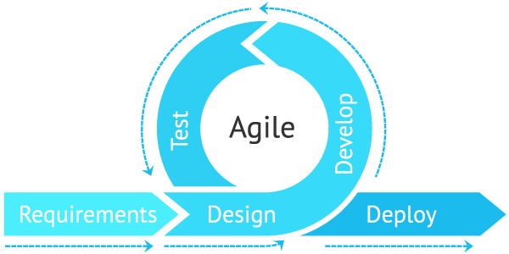

Figure 3a. Agile Software Development Methodology

1. **Requirements** - The researchers conducted interviews with end users as to what is their image of the output of the proposed system and each of its components. The discussions here were then taken into account for each components’ design phase.
2. **Design** - the design of each component is then determined from the planning phase and the necessary technologies are discussed in the requirements analysis section of this document.
3. **Develop** - the created designs were then coded into software codes and the needed backend platforms were also installed on development machines.
4. **Test -** Before Deploying the prototype for end user reviews, design and functionality tests were conducted by the researchers to ensure proper system component functionality.

After testing from the researcher’s side, the prototype is then presented to the end users to test to gain unbiased test results. For every component that gained an unsatisfactory result, the development process for that component will return back to the requirements analysis stage but with more reliable data for design this time.

1. **Deploy** - after all components have been approved by the end users, the web-based system is then deployed to a production server that is accessible by the public internet.

## REQUIREMENTS ANALYSIS

The requirements for the development of the PSU-Bataraza Accreditation Website was formulated based on the interview done by the researchers with the system’s end users (see Appendix I for the interview). This section of the document describes the motivation behind the requirements for the proposed system. It describes the description of the existing system and how the interview played a vital role for the requirements analysis of the system.

### Description of the Existing System

As per the interview conducted, the university staff does a manual way of storing and retrieving accreditation documents (see figure 3b). Upon request, they will look for the storage medium of the requested document from the cabinets/devices where it is stored and send them to accreditors via gmail or messenger. The time it takes to reconcile the whole process is dependent on how fast they can locate the needed document from their physical storages. The documents however, are prone to file corruption from viruses or physical damage as they are electronically stored on physical storages. This situation has posed a problem for the university staff as accreditation documents must be presented whenever needed.

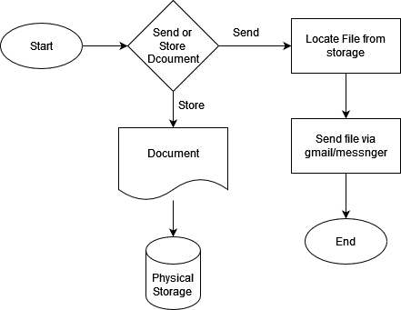

Figure 3b. Existing System for the accreditation process from university staff’s perspective.

On the accreditor’s end, figure 3c below shows the existing process.



Figure 3c. Existing System for the accreditation process from the accreditor's perspective.

This study was motivated by the efforts of the university accreditation personnel to achieve a system that would serve as a ‘1-stop shop’ for accreditors and university staff. The proposed system would try to eliminate the need for physical storages and make the accreditation documents available whenever needed by the accreditors.

### Description of the Proposed System

The envisioned web-based system by the researchers would ideally store the documents’ electronic copies in a database and storage in the cloud to alleviate the risk of document loss and gain faster data retention and retrieval processes. Figure 3d shows the flow of the document processing and access scenario in the proposed web-based system.

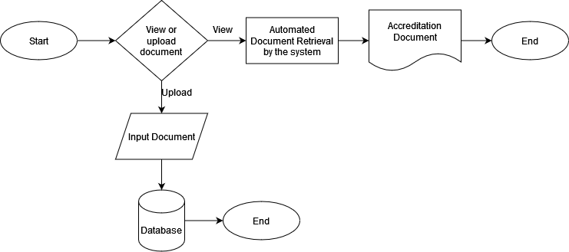

Figure 3d. Image illustration of PSU-Bataraza Accreditation Website

#### Use Case Scenario

To further depict the functionality and utilization of the proposed system, we provide use-case scenarios for end users of the system.

##### University Staff Use Case

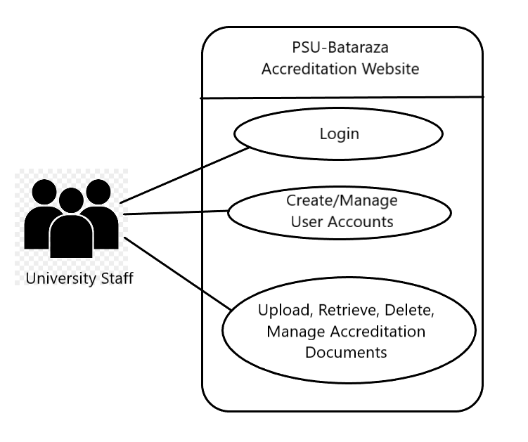

Figure 3e. Psu-Bataraza Accreditation Website Use-Case Scenario For University Staff

##### Accreditors Use Case

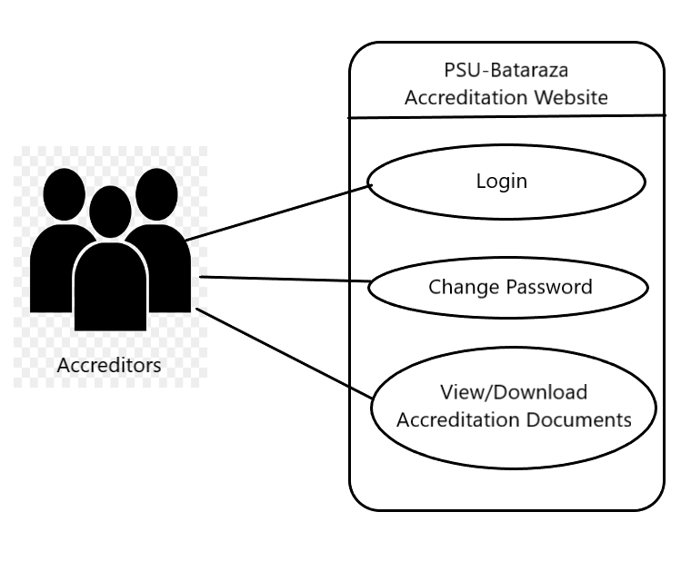

Figure 3f. Psu-Bataraza Accreditation Website Use-Case Scenario For Accreditors

##### DATA FLOW DIAGRAM OF PSU-BATARAZA ACCREDITATION WEBSITE

The data flow diagram below (figure 3g) shows the high level view of the proposed system in terms of its usage. The detailed flow for each user is then elaborated in the flow charts following, in context to the user.

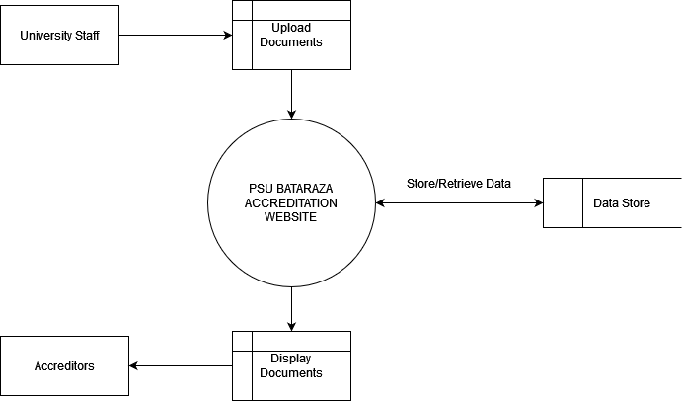

Figure 3g. Psu-Bataraza Accreditation Website Data Flow Diagram

##### FLOW CHART OF PSU-BATARAZA ACCREDITATION WEBSITE

To elaborate further on the process of the system, a deeper illustration of the activities in the system is shown as a flow chart for both end users. Figure 3f shows the flow for the accreditor usage of the system.

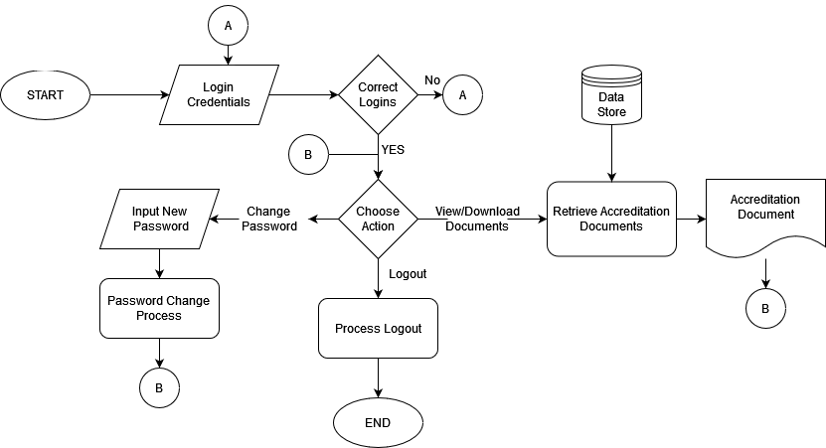

Figure 3h. Flow chart of accreditor system usage

The accreditors will only have access to the accreditation documents and their own accounts in the system. The University staff however, will have document management access in the system to be able to properly organize the correct documents for the accreditors to see as seen in figure 3i.

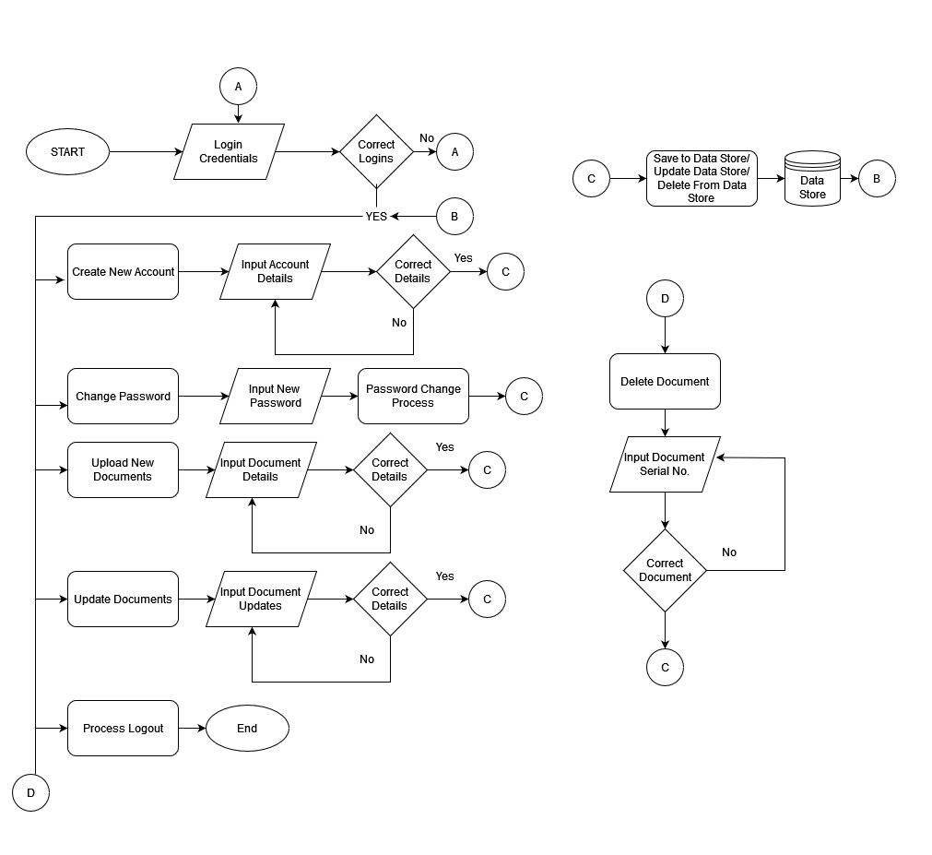

Figure 3i. Flow chart of University Staff system usage

##### Entity Relationship Diagram

The database design for the entities (database tables) in the proposed system are shown below as well as their relationship with other entities.

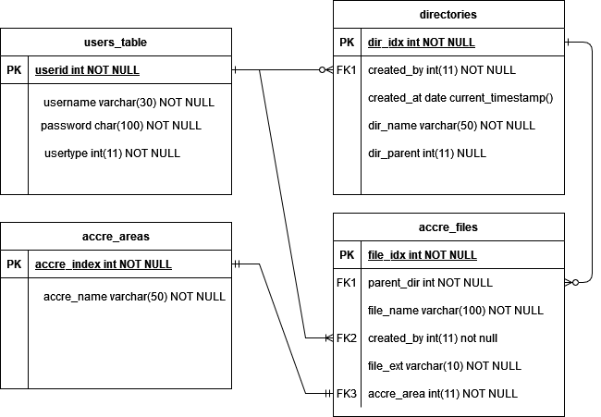

Figure 3j. Entity Relationship Diagram of PSU-Bataraza Accreditation website.

As such, the following are the description of entity relationships:

* users_table - has 1 to many relationship
* directories_table - has 1 to many relationship
* accre_files - has 1 to many relationship
* accre_areas - has 1 to 1 relationship

##### Data Dictionary

In this section, the entities mentioned in figure 3j are described in respect to their field values.

###### **Users Table**

| **Field Name** | **Data Type** | **Data Format** | **Field Size** | **Description** | **Example** |
| --- | --- | --- | --- | --- | --- |
| userid | integer | NNNNN | 11 | The primary key for the users table which is used as foreign keys in other tables as well | 1 |
| username | Varchar |  | 20 | The username used in the login module | admin |
| password | char |  | 100 | The field to store encrypted password value | $2y$10$KXVBmY3VgTmFe9U7/2EcO.UVccu3HZ2T8q4gj.ePgZxmU9z9QEu.. |
| usertype | int | N | 11 | The identifier if a user logging in is an accreditor or staff | 1 for staff  2 for accreditor |

Table 3.1 Users table data dictionary

###### **Directories table**

| **Field Name** | **Data Type** | **Data Format** | **Field Size** | **Description** | **Example** |
| --- | --- | --- | --- | --- | --- |
| dir_idx | int | NNN | 11 | Primary key for the directories table | 1 |
| dir_name | varchar |  | 50 | The name of the directory/folder in the system | Accreditation Folder |
| dir_parent | int | N | 11 | The identifier if a directory has a parent directory | 1 |
| created_at | date | YYYY-MM-DD |  | The date stamp when the directory was created | 2022-07-20 |
| created_by | int | NNN | 11 | The id of the user who created the directory | 1 |

Table 3.2 directories table data dictionary

###### **accre_files table**

| **Field Name** | **Data Type** | **Data Format** | **Field Size** | **Description** | **Example** |
| --- | --- | --- | --- | --- | --- |
| file_idx | int | NNN | 11 | The primary key for the file record in the database | 1 |
| file_name | Varchar |  | 100 | The contextual name of the file to be uploaded | Vision Mission document |
| parent_dir | int | NNN | 11 | The id of the parent directory of the file | 1 |
| created_at | date | YYYY-MM-DD |  | The date stamp when the file was uploaded | 2022-07-20 |
| created_by | int | NNN | 11 | The id of the user who uploaded the file | 1 |
| file_ext | varchar |  | 20 | The file extension of the file for quick categorization | application/pdf |
| accre_area | int | NNN | 11 | The accreditation area id to provide more context to the file | 1 |

Table 3.3 accre_files table data dictionary

###### **accre_areas table**

| **Field Name** | **Data Type** | **Data Format** | **Field Size** | **Description** | **Example** |
| --- | --- | --- | --- | --- | --- |
| accre_index | int | NNN | 11 | The primary key for the accre_areas table referenced in the accre_files table | 1 |
| accre_name | varchar |  | 50 | The name of the accreditation area that a file has been uploaded under | Physical Plants Facilities |

Table 3.4 accre_areas table data dictionary

## REQUIREMENTS DOCUMENTATION

### Output Requirements

The proposed PSU-Bataraza Accreditation website is envisioned to have 4 basic modules as per the university staff’s requirements. These modules are:

1. Login Module - as the system will be storing confidential files, a login system must be in place so only authorized people can access those documents.
2. User Account Management Module - users must have an option to manage their own passwords to enforce account confidentiality.
3. Document management module - university staff must be able to:
   1. Upload electronic copies of accreditation documents.
   2. Edit said copies in terms of their document details.
   3. Delete documents that are deemed erroneous or redundant.
4. Document View Module - both the university staff and accreditors should be able to view the uploaded documents within the system which are categorized by their respective accreditation areas.

### System Requirements

The system requirements section is the needed software language and equipment to develop and deploy and utilize the PSU-Bataraza Accreditation Website. It details how each component is to be utilized to achieve the goal of the proposed system. Table 3.1 below shows the details for the system requirements.

| Language/Technology | Utilization |
| --- | --- |
| HTML (HyperText Markup Language) | is the readable code by internet browsers to display needed information. This will be the base technology for the development of the system. |
| CSS (Cascading StyleSheets) | Is the styling component for HTML which makes it user-friendly for its users. |
| Javascript | Is the language which makes html or website elements have the capability to interact with its users. |
| PHP (PHP: Hypertext Preprocessor) | is a widely-used, open source scripting language. PHP scripts are executed on the server. PHP is free to download and use. This will be used for backend operations such as database and file operations. |
| mySql (database management system) | A database is a collection of data that is arranged in a structured manner. We are able to add, delete, modify and process the data stored in the computer database with the help of a database management system such as MySQL server, etc. |
| XAMPP | is a free and open-source cross-platform web server solution stack package developed by Apache Friends, consisting mainly of the Apache HTTP Server, MariaDB database, and interpreters for scripts written in the PHP and Perl programming languages. This will be installed on the development and production server for the system to be accessed. |
| Machine Requirements | Usage |
| Laptop or PC | Will be used to house the web-based system and its database. It is ideally intended to be accessible within a local area network for users to access it on their own devices. Through these devices is also where end users can access the system. |
| Internet Browser | A software that is capable of translating HTML text into user-friendly website components e.g. Chrome, Firefox, Opera, etc. |
| Network Connection | As the system will be deployed on a server setting, a network connection is required from the users to be able to access the system. |
| Web Hosting (For Actual Deployment) | A service from the web host providers around the world to host website files for it to be accessible on the internet |
| Domain Name (e.g. www.google.com) | A unique domain name for users to access the website online |

Table 3.5 System Requirements for PSU-Bataraza Accreditation Website

## DESIGN OF SOFTWARE, SYSTEMS, PRODUCTS AND/OR PROCESSES

How the software requirements are going to be used is best presented in a system architecture view. Figure 3k shows how each language/technology is contributing to achieve the system functionalities.

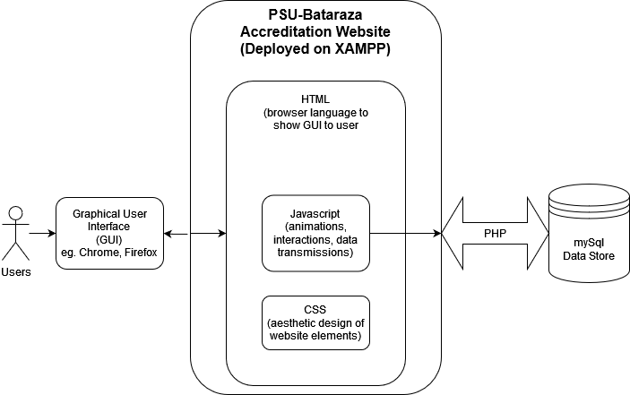

Figure 3k. System Architecture of PSU-Bataraza Accreditation Website

Users will access the system through the use of web browsers in their laptops or PC. The visual design of the website is handled by the CSS and the interactiveness such as system responses to user actions (e.g. button or link clicks) is handled by Javascript. All data transactions are then handled by Javascript and PHP for data formatting and authentication. PHP then is responsible for communicating with the data store (mySql) such as querying if the submitted user login credentials are correct or not. PHP and Javascript are also responsible for creating, deleting, updating, and finding the right document as queried by the user. In simpler terms, Javascript accepts commands from the users and relays it to PHP who then sends and receives data from the data store; Javascript is inside the web browser (front end) while PHP works in the backend or within the server.

## DEVELOPMENT AND TESTING

The development and testing as specified from the methodology section of this chapter is the development of each module (see Output Requirements) and testing its functionalities (done by the researchers) and then later on presented to the end users for feedback.

## DESCRIPTION OF THE PROTOTYPE

This section shows the initial prototypes of the system during its development stages.

### The login module

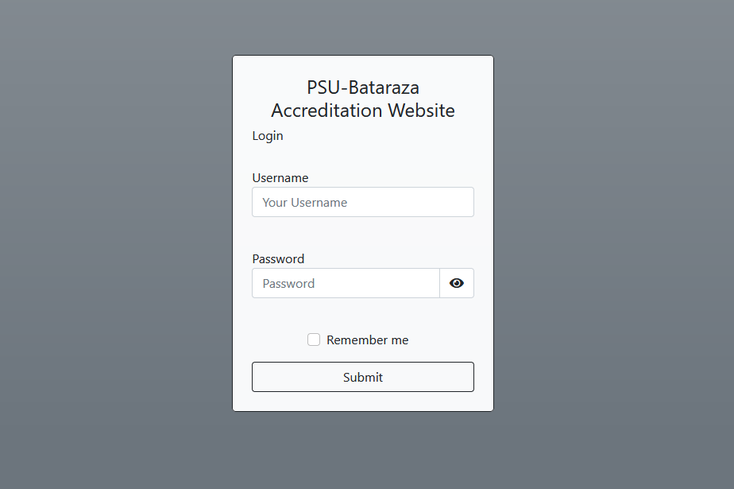

### Documents dashboard module

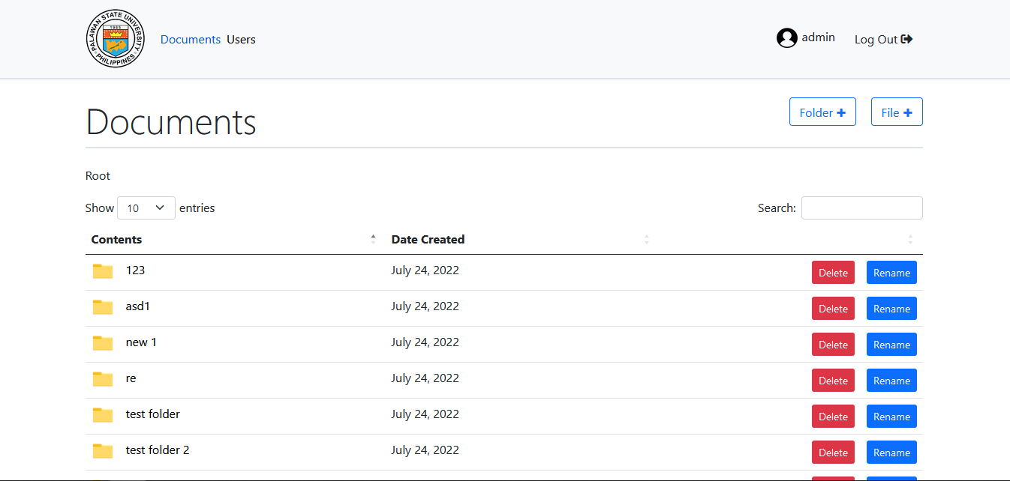

### Users Module

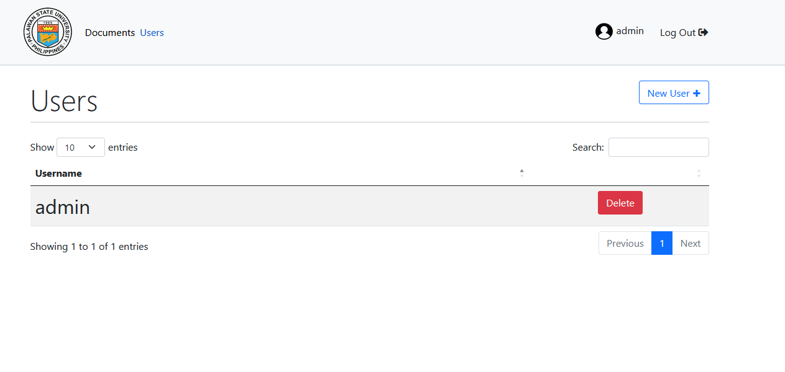

### File Upload module

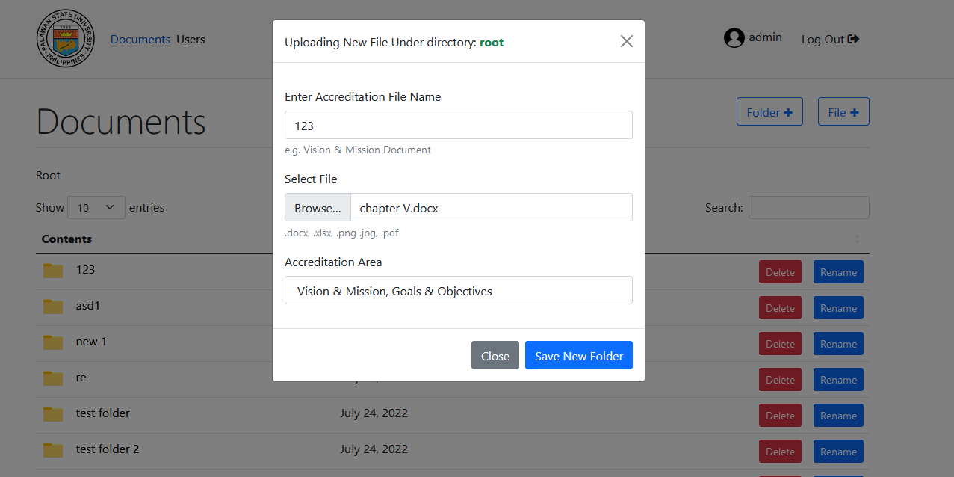

### Create Directory module

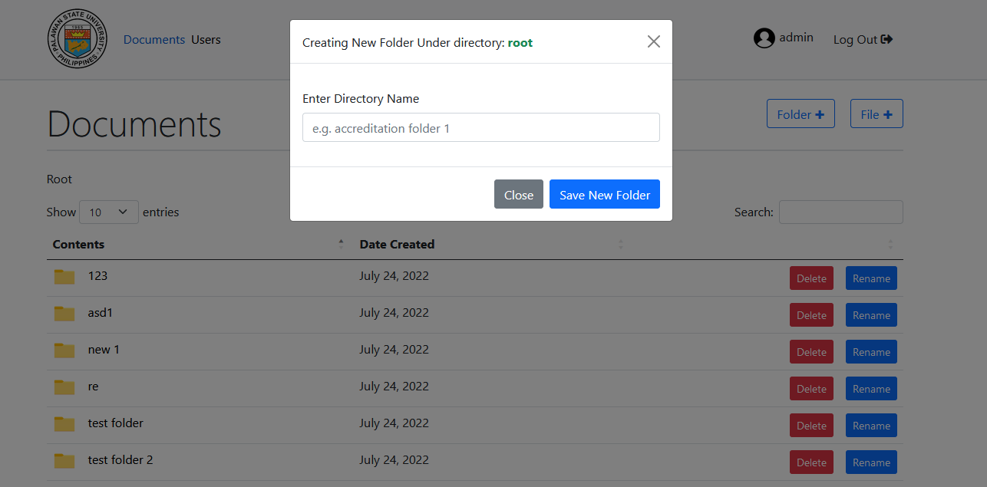

## COST BENEFIT ANALYSIS

Table 3.6 shows the cost benefit analysis of implementing the proposed system as a replacement for the traditional manual way being practiced currently in PSU-Bataraza in terms of organizing accreditation files.

| **Existing System** | **Proposed System** |
| --- | --- |
| External hard drive - 1,500php (subject to repurchase if drive is damaged) | Web Hosting (Z.com business plan) - 1,849php Good for 1 yr with free domain name +20,000php development fee |
| Filing Cabinet - 7,500php (subject to repurchase if cabinet is damaged) | Recurring cost of 849php/year after 1 year |
| Total 9,000php for 1 year and unknown recurring cost incursion for the next 3 yrs | Total 1,849php for 1 year and a total recurring cost of 2,547php for the next 3 yrs. |
| Total cost for the next 4 yrs: 9,000php + (estimated 2x replacement of equipment) = **27,000php** | Total Cost for the next 4 years  **Fixed cost of 24,396php**. |

Table 3.6 Cost Benefit Analysis

The thing to note is that the proposed system has a fixed cost as dictated on table 3.6 while the existing system has an unstable minimal cost of 27,000 php in which the recurring cost is likely to happen more than the estimated time of recurrence due to unforeseeable circumstances and highly plausible damages that may happen especially to the hard drives as they are very prone to viruses and corruption.

## IMPLEMENTATION PLAN

After the system testing has yielded satisfactory results, an implementation plan is then formulated by the researchers to see overall functional effectiveness of the system. The reader should note that this implementation plan is in the context of an actual deployment to a Web hosting with a registered domain name (e.g. www.psubataraza.com)

| Strategy | Activity | Involved | Duration |
| --- | --- | --- | --- |
| Approval from the university to acquire web hosting service as well as purchase a domain name for the system | Letter to Administration | Researchers, Administrator | Indefinite |
| System Installation | The installation of the database and website files on the web hosting service after it is purchased. | researchers | 1 Day |
| Domain Name Propagation | The pointing of the purchased domain name to the IP address of the web host. | researchers | 1-24 hrs |
| 2 Day Training | The training of the rest of university users of the system | Administrators, researchers | 2 days |

Table 3.7 Schedule of activities for the implementation plan